Installation of the Arduino Software
Lesson 1 Button
- www.sunfounder.com
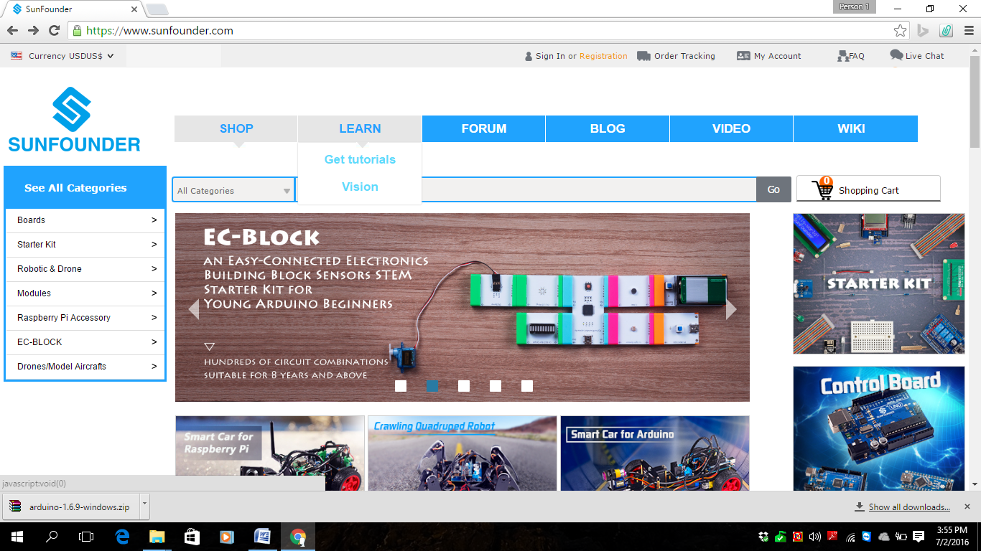
- LEARN -> Get Tutorial
- Basic Kit for Arduino
- Download Basic_Kit_for_Arduino.zip
- Install the Arduino
- Plug the Interface to PC
- Verify port

- 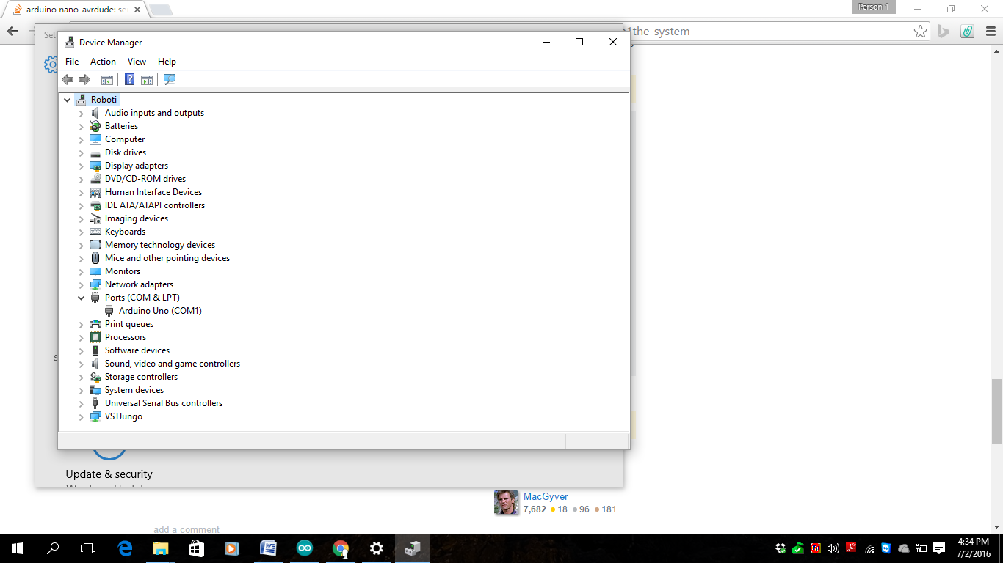

- Complete the scheme
- 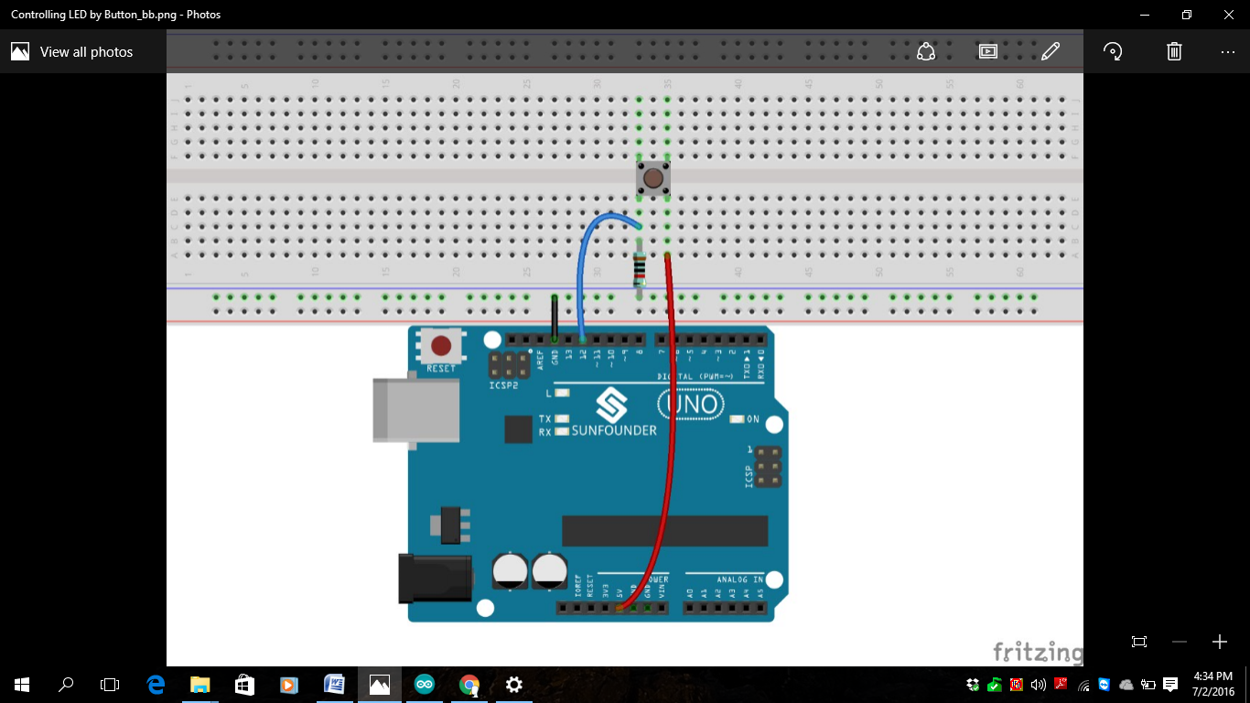
- Compile and upload the file
- 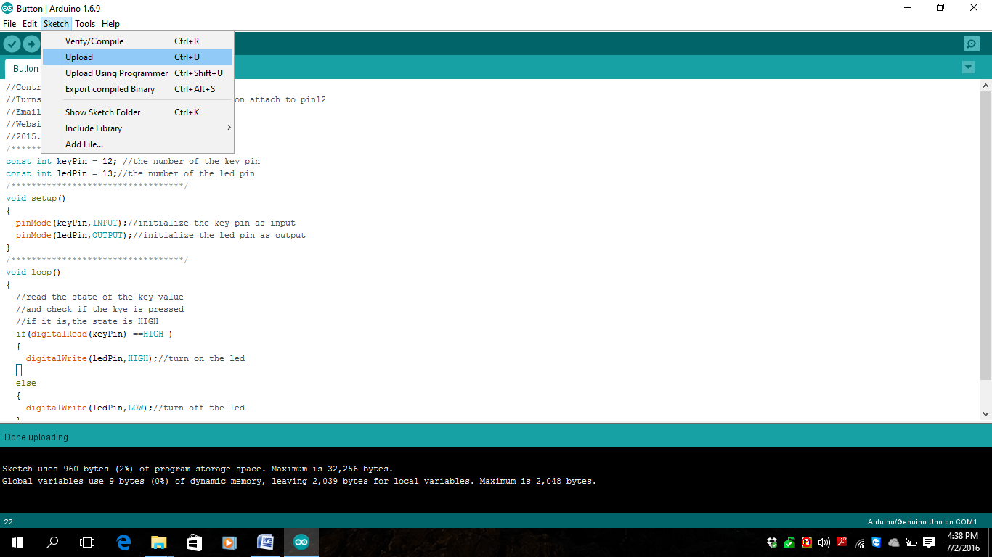

- Test the Circuit by pressing the button
